**Social media strategy – Final Exam**

Duration: 4h

Group of 4 maximum

All documents allowed

Company: Hotel Château Laurier – Québec

<http://hotelchateaulaurier.com/>

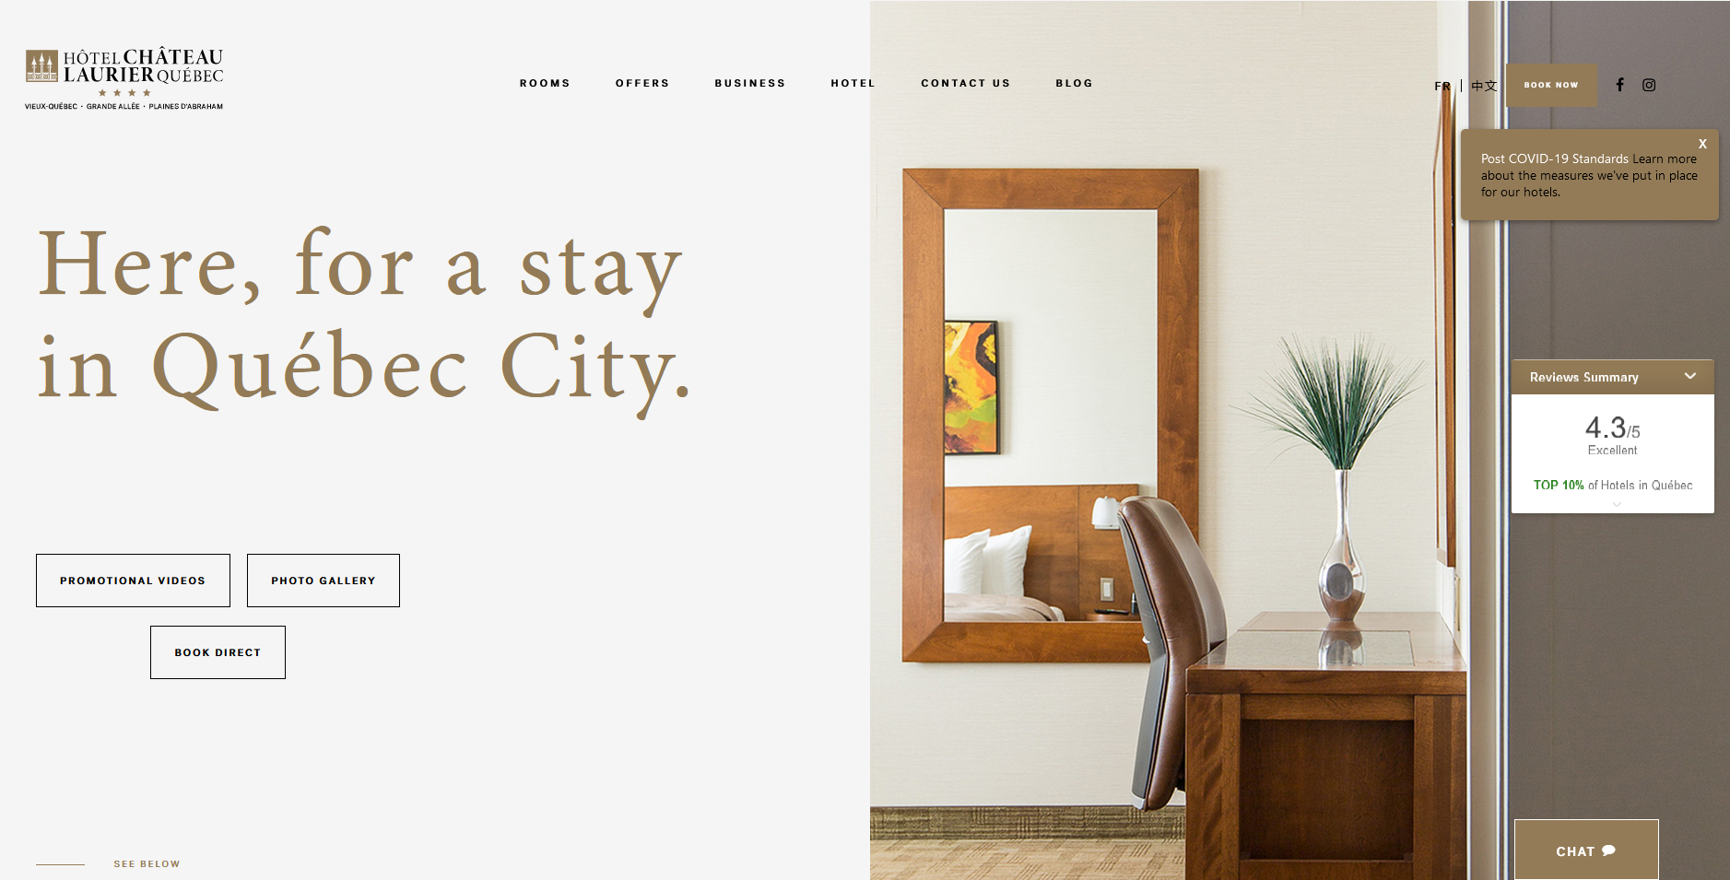

Johanne Caron, head of sales and Marketing, is asking you to help her regarding the digital strategy of the Hotel.

The Château Laurier, a 4 stars hotel, is one of the most famous hotels in Quebec City. However, it faces some critical issues that, Johanne thinks, could be solved through digital actions.

Among them:

1. Johanne wishes to know the « digital position » of her hotel compared to her main competitors;
   1. What are the top trends in the industry that the hotel could implement?
2. The new version of the website is still not perfect for her. Any suggestions to improve it are welcome (what are the good tips from the competitors’ websites);
3. Lack of presence as well as a lack of quality on Social Media. They require advices on how to use them and how to communicate through them (content strategy);
   1. Most clearly
      1. Selection of social media platforms (Are they all relevant?)
      2. Improvement of Digital communication (schedule and content)
      3. CRM online?
4. The hotel uses some social platforms in order to help sell rooms (such as TripAdvisor) but needs a real strategy on these aggregator platforms;
5. During the season, the hotel has some “dead periods”. More precisely from November to end of January and from end of February to April. So, the hotel is not running at his full potential;

Right now, Johanne is alone to do most of the communication strategy but is directly linked to the CEO and has his agreement for a new strategy mainly using mainly digital channels.

Your need to

1. Structure an audit of the digital positioning of the hotel
   1. Business model canvas
   2. Social media;
   3. Website;
   4. SEO;
   5. Any other element you may think of.
2. Address the 5 issues presented in the document

More precisely, based on your audit, structure its digital positioning

* 1. The website
     1. Content and ergonomics
     2. Languages
     3. Integration of social networks
     4. Integration of content from addicts and customers
  2. Digital communication strategy
     1. Relevance of the current presence on the networks (POEM)
     2. Proposal of a content strategy on 2 main networks starting in March 2023 (over 6 months period)

1. Propose a prioritization of your recommendations

Feel free to **add any other element** you think could help the hotel.

Good luck

**Your document must be a pdf document (start either with Power Point or a Word document).**

**Send the document to** [**vdutot@em-normandie.fr**](mailto:vdutot@em-normandie.fr)

**The title of your message should be – Masterclass Chateau Laurier**

**Be sure you ADD all your names in the document**